**Assignment – 3**

|  |  |
| --- | --- |
| Assignment Date | 01 October 2022 |
| Student Name | Santhos Kamal.A.B |
| Student Roll Number | 312319104148 |
| Maximum Marks | 2 Mark |

**Question 1:**

Create a Bucket in IBM object storage

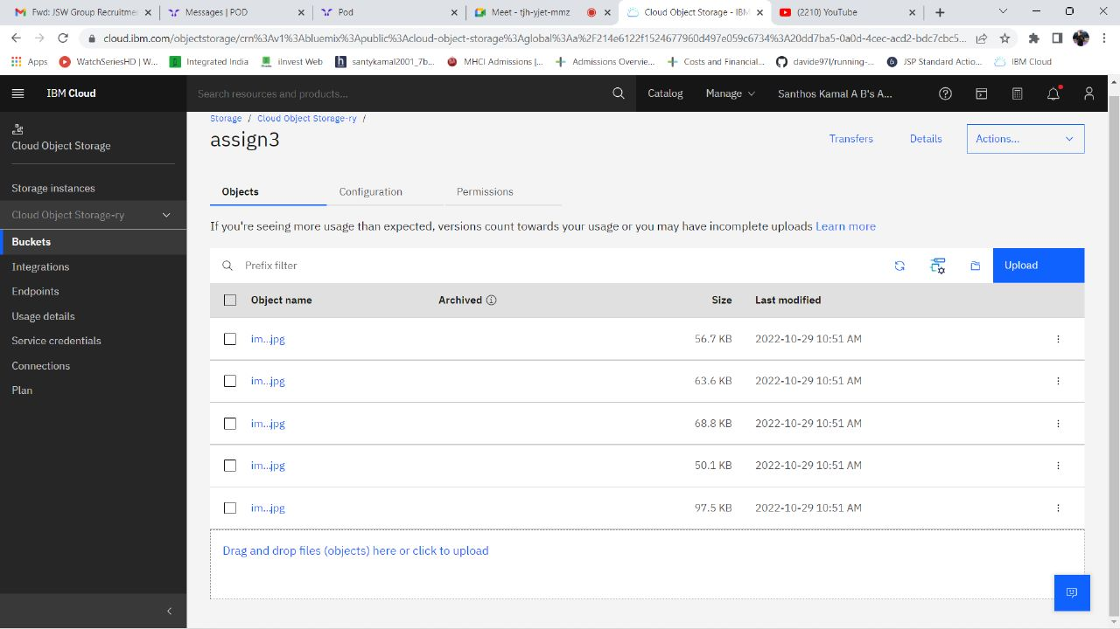

**2.Upload 5 images to IBM object storage and make it public. write html code to displaying all the 5 images:**

**Html code**

<html>

<head>

<link rel="stylesheet" href="style.css">

</head>

<body>

<img src="https://assign3.s3.jp-tok.cloud-object-storage.appdomain.cloud/img1.jpg" alt="loading"/>

<img src="https://assign3.s3.jp-tok.cloud-object-storage.appdomain.cloud/img2.jpg" alt="loading"/>

<img src="https://assign3.s3.jp-tok.cloud-object-storage.appdomain.cloud/img3.jpg" alt="loading"/>

<img src="https://assign3.s3.jp-tok.cloud-object-storage.appdomain.cloud/img4.jpg" alt="loading"/>

<img src="https://assign3.s3.jp-tok.cloud-object-storage.appdomain.cloud/img5.jpg" alt="loading"/>

</body>

</html>

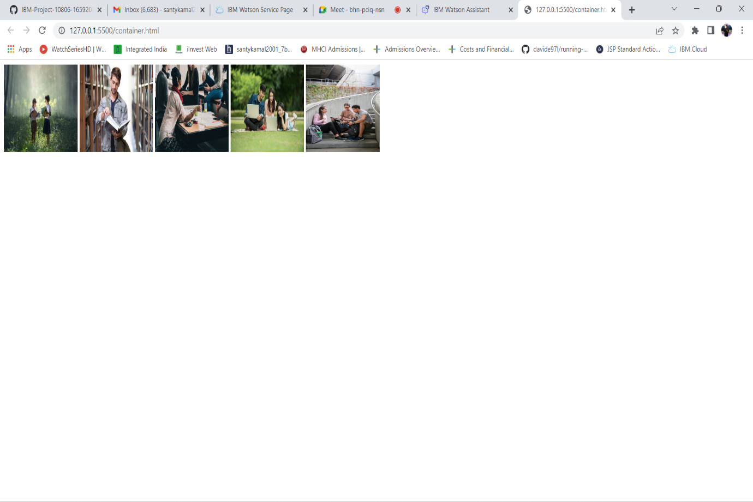

**3.Upload a CSS style sheet to the object storage and use the same page in your HTML**

img {

width:150;

height:150;

}

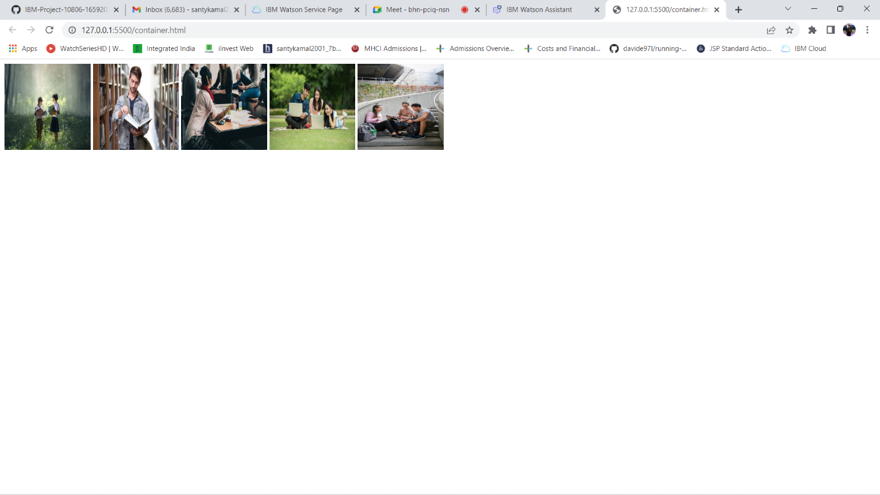

**4.Design a chatbot using IBM Watson assistant for hospital. Ex: User comes with query to know the branches for that hospital in your city.**

https://web-chat.global.assistant.watson.appdomain.cloud/preview.html?backgroundImageURL=https%3A%2F%2Fau-syd.assistant.watson.cloud.ibm.com%2Fpublic%2Fimages%2Fupx-829d27ca-0c33-46e4-b1ae-6450b0d0b56f%3A%3A0b09532a-d699-45a8-bf7a-aacf88e20cd1&integrationID=81e7a0b6-04a7-4fe8-b9ca-4ea025f00fa1&region=au-syd&serviceInstanceID=829d27ca-0c33-46e4-b1ae-6450b0d0b56f

**5.Create Watson assistant service with 10 steps and use 3 conditions in it. Load that script in HTML page.**

